NodeJs Commands
1. Get help: node –h
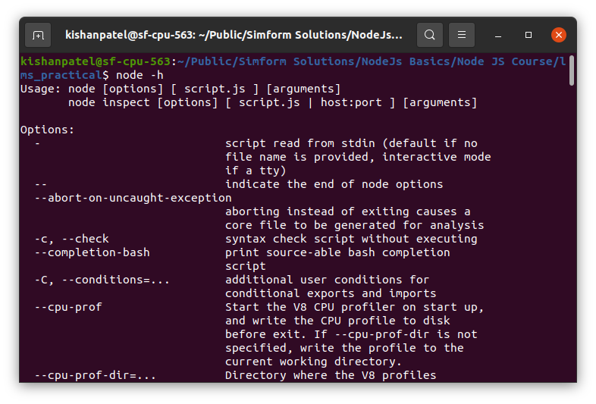

2 Run script: node script_name.js

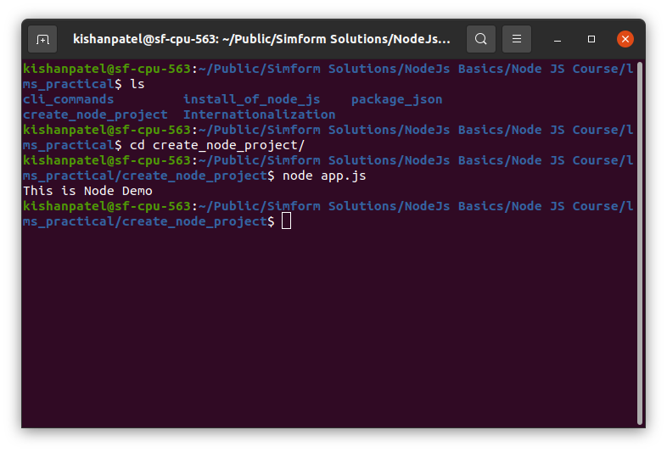

3. Check syntax without executing script: node –c app.js
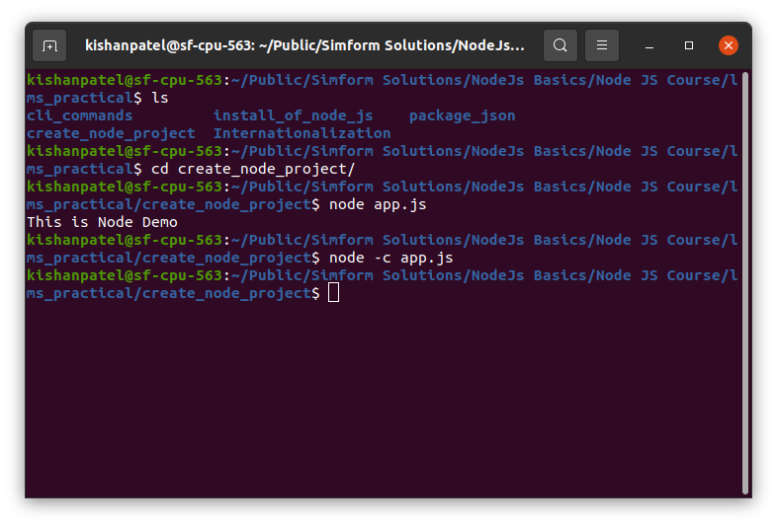

4. print V8 options : node –V8-options

5: print node version: node –v

